AI for Developers – January 2026
Individual Project Assignment
MarketPl.ai

Project Description
MarketPl.ai is a web application for exploring how investment strategies would have performed using historical stock and ETF price data. It is designed for analysis and learning: users select a symbol and time period, run simulations under consistent assumptions, and review outcomes through clear charts, metrics, and trade history.

Users start by importing historical price data from CSV files and monitoring import progress and status. Once data is available, they can browse symbols, filter by date ranges, and inspect price series in a data explorer. Backtesting features allow users to choose a strategy (e.g., Buy and Hold, Dollar-Cost Averaging, Moving Average Crossover, RSI, Bollinger Bands), configure strategy parameters, and run simulations for a single symbol or a small weighted portfolio. Results include an equity curve, key performance and risk metrics, and a trade log, with the option to compare multiple strategies side-by-side on the same dataset.

System Architecture – Modules
MarketPl.ai is organized into a set of modules that map directly to the main user workflows: importing historical price data, exploring it, and running strategy simulations to compare outcomes.
The modules below are described in terms of capabilities and user interactions (not internal implementation details). For AI assistance, we used GitHub Copilot in VS Code throughout the implementation, plus lightweight project customizations under the project’s .github/ folder: custom agents to guide frontend/backend work patterns, and reusable skills to automate repetitive tasks (DOCX editing, CSV/data processing) and keep backtesting/finance conventions consistent.
Frontend (User Interface): Provides the main navigation and screens for Import, Data Explorer, Backtest, and Portfolio workflows. The focus is on clear configuration forms, readable tables and charts, and immediate feedback (loading states, validation messages, and progress indicators) during longer operations like imports and simulations.
Backend (API and Workflow Orchestration): Exposes a consistent API consumed by the UI to upload data, query symbols and prices, and run backtests. It enforces input validation (date ranges, symbols, and strategy parameters) and returns user-oriented error messages when something is invalid or missing.
Data Import and Processing: Handles CSV uploads and processes large files in a way that stays responsive for the user. Imports are tracked with status and progress so users can see how much data has been processed and whether an import completed or failed. Users can also delete an import, which removes its associated records and updates the UI accordingly.
Data Storage and Query Layer: Persists imported price records and serves fast, paginated queries for the Data Explorer. It also provides a symbol catalog (symbol plus display name and record counts) so users can quickly find instruments with available data. For a smooth UI experience, expensive aggregate queries are cached briefly and refreshed after imports or deletions.
Backtesting and Analytics (Statistics): Runs strategy simulations over a selected date range and produces outputs that are easy to interpret: an equity curve, summary performance and risk metrics, and a trade log. The module supports multiple strategies, side-by-side strategy comparison on the same dataset, and small portfolio simulations using weighted holdings with optional periodic rebalancing.
Data Gathering Utilities: A separate set of scripts used to collect, merge, and prepare datasets into the CSV format expected by the Import workflow. This keeps data acquisition and preparation independent from the core application and allows repeating dataset updates without changing the product experience.
Quality and Developer Tooling: Provides a predictable local development setup and guardrails so changes are easier to verify. This includes simple run commands, basic health checks for quick sanity validation, and static checks (type checking and linting) to catch issues early.

Development Process per Module
Common approach (applied to all modules): we started from user-facing requirements, drafted a short plan, and iterated in small changes until the feature worked end-to-end. We relied on GitHub Copilot in VS Code (plus our custom agents/skills under .github/) to scaffold code, refactor safely, and keep frontend and backend contracts aligned.
- Frontend (User Interface)
Approach and reasoning: Designed the UI around the main user tasks (Import → Explore → Backtest → Portfolio), keeping forms simple and feedback immediate (loading/progress/error states). We aimed for clarity over complexity, with explainers for strategies/metrics to make the results understandable.
Step-by-step workflow: Asked Copilot to scaffold the React app structure and routing, generate page layouts for Import/Data/Backtest/Portfolio, wire typed API calls, then iterate on UX details (tables, charts, tooltips, and validation) based on runtime behavior.
Testing strategy: Type-checking and linting (npx tsc --noEmit, npm run lint) plus manual smoke tests in the browser: upload CSV, browse data pages, run backtests, and verify charts/metrics update correctly.
AI tool choice: GitHub Copilot (fast in-editor iteration, good at scaffolding UI and TypeScript wiring, and worked well with our custom frontend agent prompts).
Key prompts/interactions: “Initialize FE/BE architecture (React + Vite, FastAPI) with plain setup.” “I want an elegant informative tooltip on hover over a strategy or metric explaining how it works.” “Create a new Portfolio page supporting multiple tickers and percentage weights.”
- Backend (API and Workflow Orchestration)
Approach and reasoning: Defined a small set of endpoints matching the UI workflows (imports, symbol discovery, price queries, backtests). Emphasis was on predictable request/response shapes, clear validation errors, and stable behavior for long-running operations (imports and deletions).
Step-by-step workflow: Prompted Copilot for the initial API skeleton, then generated routers and schemas for each feature area. Iterated by running the server, checking OpenAPI docs, and adjusting validations and response payloads until the frontend integration was smooth.
Testing strategy: Backend smoke checks (start the server, /health and /health/db, plus exercising the key endpoints via the UI and basic curl requests). We also validated that the app boots cleanly after changes and that error cases return readable messages.
AI tool choice: GitHub Copilot (quick scaffolding for endpoints/schemas and efficient iteration inside VS Code; worked well with our backend-oriented agent prompts).
Key prompts/interactions: “Initialize FE/BE architecture with FastAPI + React.” “Add performance optimizations like caching and chunking.” “Add portfolio backtesting for multiple tickers with weights.”
- Data Import and Processing
Approach and reasoning: Treated CSV imports as potentially large and long-running. The goal was a responsive user experience: upload once, get an import id, show progress/status, and allow deletion/cancellation without leaving partial data behind.
Step-by-step workflow: Asked Copilot to plan the end-to-end import feature (UI + API), then generated upload handling, background processing, chunked parsing, progress tracking, and the UI polling loop. Iterated on edge cases: invalid headers, failed imports, and deletion during processing.
Testing strategy: Imported small and large CSV samples, verified status transitions (pending/processing/completed/failed), and confirmed data appears in the explorer. Tested deletion and ensured the UI and symbol list update afterward.
AI tool choice: GitHub Copilot (helpful for generating the repetitive parsing/progress plumbing and iterating quickly when performance or edge cases surfaced).
Key prompts/interactions: “Implement CSV import with no practical file size limit; store it so we can query later.” “The CSV has header: Symbol, Security Name, Date, Open, High, Low, Close, Adj Close, Volume.” “Add optimizations like chunking and caching to improve speed.”
- Data Storage and Query Layer
Approach and reasoning: Focused on fast, predictable reads for the UI: paginated price queries, a symbol catalog, and sensible defaults for common filters. Since data volume can be large, we prioritized query efficiency and stable performance.
Step-by-step workflow: Prompted Copilot to set up a non-relational data store, then added indexes and refined queries (skip/limit paging, date filtering, symbol discovery). Where a query was expensive, we added short-lived caching and invalidated it after imports/deletes.
Testing strategy: Verified pagination and filters via the Data Explorer UI, tested symbol list refresh after imports/deletes, and sanity-checked performance by running representative queries on larger datasets.
AI tool choice: GitHub Copilot (helped iterate quickly on data access patterns and index suggestions while keeping the API contract stable for the UI).
Key prompts/interactions: “Use a non-relational database for the backend.” “Queries are slow; add indexes to optimize them.”
- Backtesting and Analytics (Statistics)
Approach and reasoning: Built the backtest flow as a user-configurable experiment: select symbol and date range, choose a strategy and parameters, then produce results that are easy to compare (equity curve, metrics, and trades). We kept strategy behavior and metrics consistent across runs to make comparisons meaningful.
Step-by-step workflow: Asked Copilot to extend the configuration UI, then generated the backtest engine integration, strategy selection/validation, and result visualization. Added compare mode (multiple strategies on the same dataset) and later extended the flow to portfolio simulations with weighted holdings.
Testing strategy: Manual scenario checks: ran the same symbol/date range across strategies and confirmed outputs are plausible and stable (e.g., equity curve continuity, metrics updating when parameters change). Also validated date-range availability per symbol and error handling for missing data.
AI tool choice: GitHub Copilot (strong at iterating on complex feature flows when UI, validation, and result shapes must stay in sync).
Key prompts/interactions: “Allow the user to select a time range and configure a strategy, then run a backtest and view portfolio value over time.” “Make strategies comparable; show helpful estimates/inputs for DCA.” “Add a compare mode and a portfolio backtest page.”
- Data Gathering Utilities
Approach and reasoning: Kept dataset preparation separate from the app so data acquisition can evolve without changing the product workflow. The goal was to produce a clean CSV that matches the import format and can be regenerated when the source dataset changes.
Step-by-step workflow: Asked Copilot for scripts to fetch/merge market datasets into a single CSV, then refined the output (columns, symbol naming, and file layout) until it imported smoothly in the UI.
Testing strategy: Ran the scripts locally and validated the resulting CSV by importing it into the app (no errors; symbols appear and backtests can be executed).
AI tool choice: GitHub Copilot (effective for quickly drafting one-off scripts and iterating based on real file outputs).
Key prompts/interactions: “Fetch the data from Kaggle and merge symbol history into one big CSV file.”
- Quality and Developer Tooling
Approach and reasoning: Prioritized a smooth local developer experience (simple run steps, repeatable environment, and quick sanity checks). This reduced iteration time and made it easier to validate changes across the full stack.
Step-by-step workflow: Used Copilot to keep documentation and scripts aligned with the codebase (README updates, run commands, and basic checks). Added incremental safeguards like type-checking and linting in the frontend and simple health checks in the backend.
Testing strategy: Verified the complete local flow: docker compose up for the database, start backend and frontend, run npx tsc --noEmit, and do an end-to-end manual pass through import and backtest screens.
AI tool choice: GitHub Copilot (good for keeping docs/configs in sync with the code and for fast iteration on project setup tasks).
Key prompts/interactions: “Update the README files with accurate setup/run steps.” “Add basic tests for strategies and metrics to increase confidence.”

Challenges & Tool Comparison
A section where you explain:
- The biggest challenges you encountered
- Which tool helped you the most and why
- What you would improve if you continued working on the project

Working System Evidence
Data importing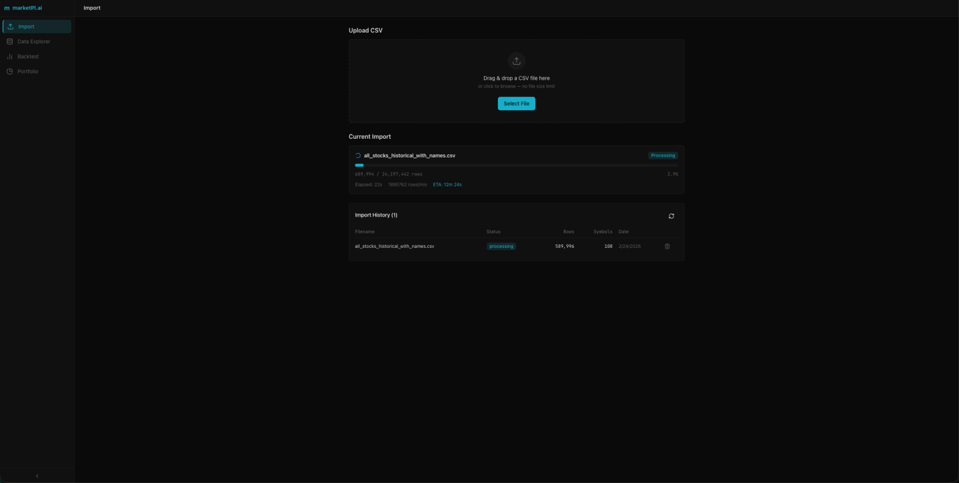

Search symbol data
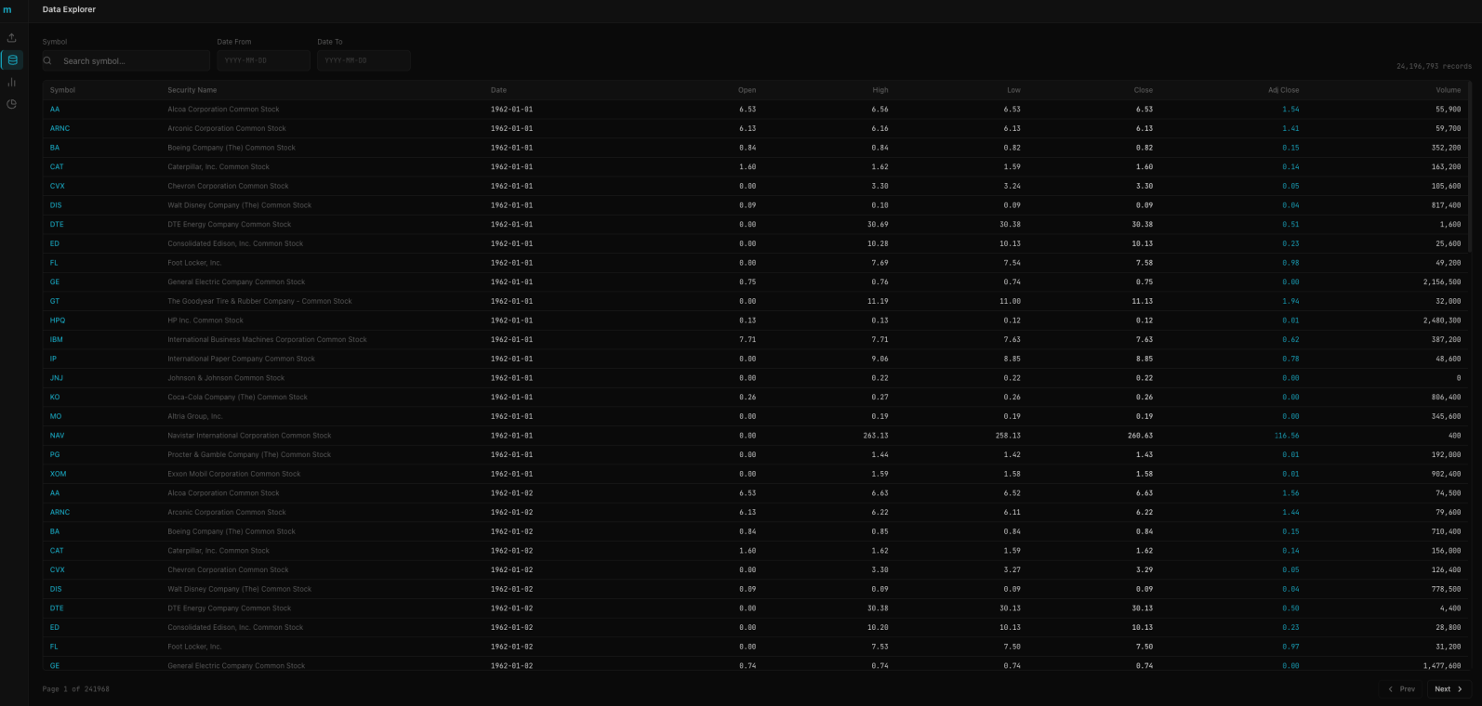
Comparison with single ticker
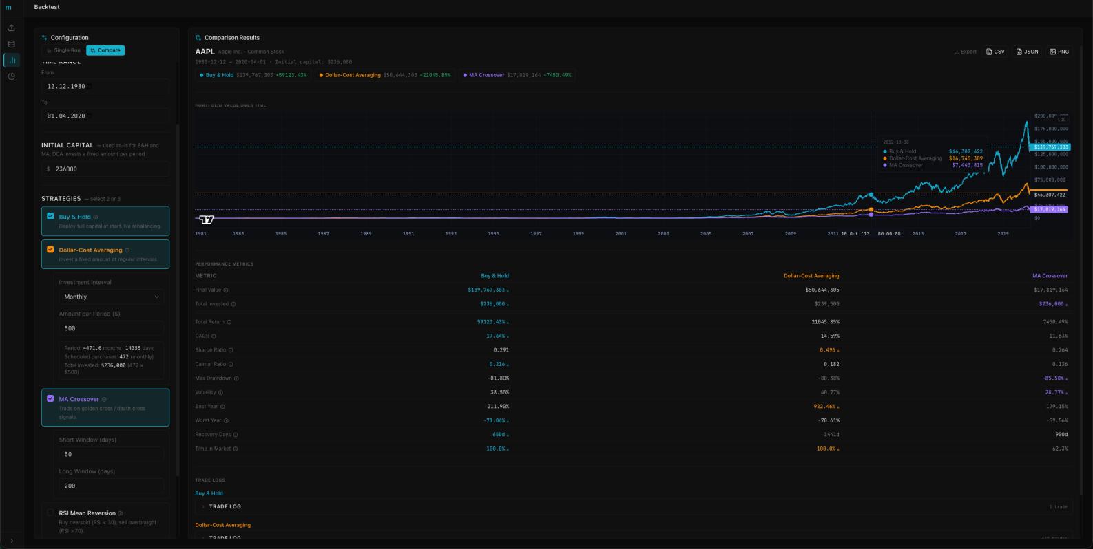
Comparison with single ticker buy logs
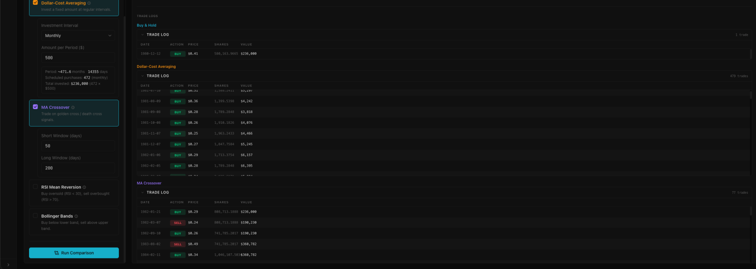

Testing strategy with multiple tickers
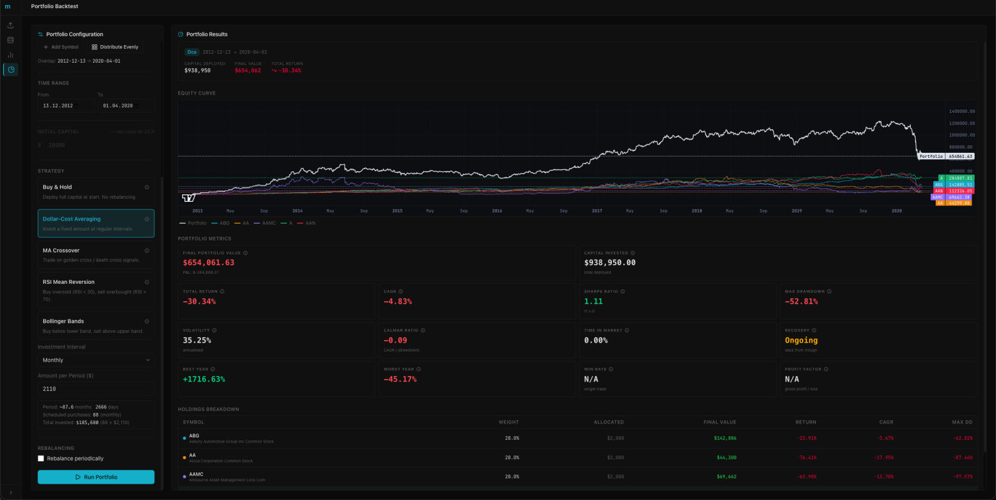

Testing strategy with multiple tickers and re-balancing
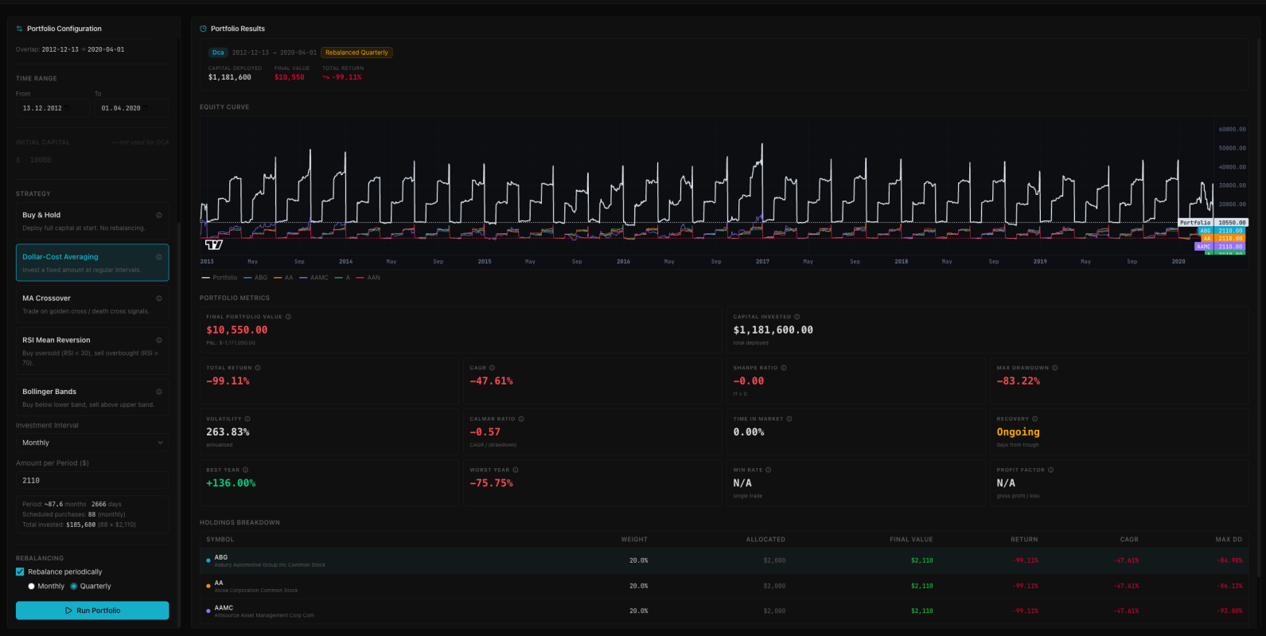

Repository
Provide a link to your GitHub repository containing the source code.

Submission Format
Link to Google Drive Document (make sure it is shared – anyone with the link can view)
Total size: typically 3-6 pages

